Name | V. Lavanya
Department | Electronics Communication Engineering
College Name | Apollo Engineering College
College Code | 2102
Naan Mudhalvan NM ID | 46260b0a905c7598b18470e6faa5b627
Gmail ID | Lavanyavijayakumar864@gmail.com
Phone Number | 8825471995

LIBRARY MANAGEMENT SYSTEM
Project Report
Project Title: Library Management System
Platform: Web Application
Technologies Used: HTML, CSS, JavaScript, GitHub Pages
Live Project URL:
https://girija00330-design.github.io/My--project-/
1. Introduction:
The Library Management System is a simple web-based application developed to manage basic library operations such as adding and viewing books.
This project is designed to help students understand the fundamentals of frontend web development and project deployment using GitHub Pages.
The system provides an easy-to-use interface where users can enter book details and view them instantly. This project demonstrates how web technologies can be used to build and deploy a functional application.
2. Objectives of the Project:
To create a simple Library Management System
To manage book details using a web interface
To reduce manual record keeping
To understand HTML, CSS, and JavaScript integration
To deploy a frontend project using GitHub Pages
3. System Description:
The Library Management System allows users to enter a book name and author name through input fields.
When the user clicks the “Add Book” button, the entered details are displayed under the Available Books section.
This is a frontend-only application and does not use any database. The project can be extended in the future by connecting it with backend technologies and a database.
4. Technologies Used:
4.1 HTML
HTML is used to create the structure of the web pages. It defines headings, input fields, buttons, and content layout.
4.2 CSS
CSS is used to design and style the application. It improves the appearance of the website by adding colors, alignment, spacing, and fonts.
4.3 JavaScript
JavaScript is used to add interactivity to the application. It handles user input and dynamically updates the list of books.
4.4 GitHub Pages
GitHub Pages is used to deploy the project online so it can be accessed through a live URL.
5. System Architecture:
The system follows a simple client-side architecture:
User → Web Browser → HTML → CSS → JavaScript → GitHub Pages
6. Advantages of the System:
Simple and easy to use
No installation required
User-friendly interface
Free deployment using GitHub Pages
Accessible from anywhere using the internet
7. Limitations:
No database connectivity
Data is not stored permanently
Page refresh clears the data
No user authentication
8. Future Enhancements:
Add backend using Node.js
Connect MongoDB database
Implement edit and delete book options
Add user login and authentication
Convert into a full MERN stack application
9. Screenshots:
GitHub page:
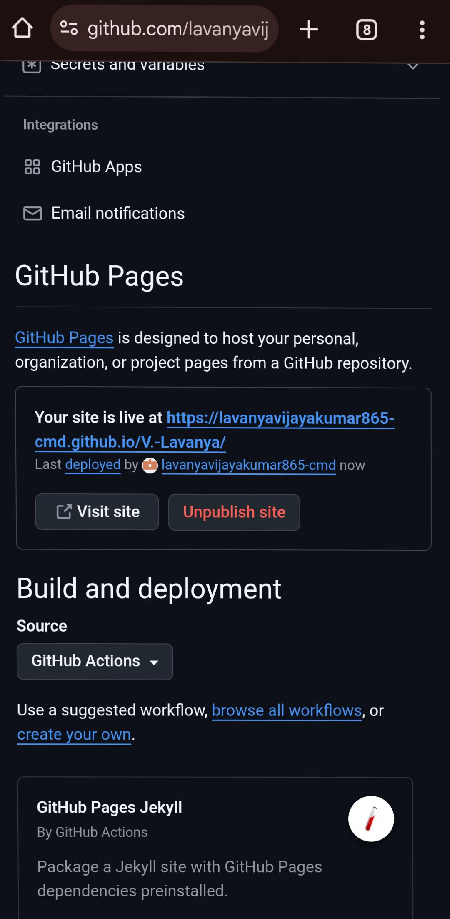

Live Website output screen


10. Conclusion
The Library Management System project successfully demonstrates how a simple web application can be developed using HTML, CSS, and JavaScript and deployed using GitHub Pages.
This project helped in understanding frontend development, basic project structure, and live deployment. It serves as a strong foundation for learning full stack development in the future.
GitHub link:https://github.com/lavanyavijayakumar865-cmd/V.-Lavanya

